Print forms
General information
Print forms are a tool for displaying information on a specific object/objects or summary information from a database in a special form. The need to use print forms was formed at a time when all key business transactions of an organization had to be printed on paper, for example, to transfer an invoice to a buyer for payment. But even today, when the use of paper documents is giving way to electronic document management, print forms are still in demand, since even to sign an electronic version of a document using an electronic signature, it is first necessary to generate this electronic document in a certain format. Some primary reporting documents to government regulatory authorities have a strict format, deviations from which are unacceptable, for example, a document containing information on taxes when buying or selling goods and services. Other documents may have a free form, usually this is related to the internal processes of an organization, for example, a form for recounting goods in a warehouse, but these can also be documents that the parties themselves agreed on the transfer, i.e. not required by law. The printing form mechanism is also used to print envelopes (and then send correspondence), price tags, labels (including printing on self-adhesive paper) and much more.
In addition to printing on a printer, the print form can also be saved to a file in various formats.
Implementation
Let's figure out how the process of forming a print form is arranged. The print form is output to a spreadsheet document. This is an internal object of the 1C platform, which is visually similar to an Excel or Google Sheet document.
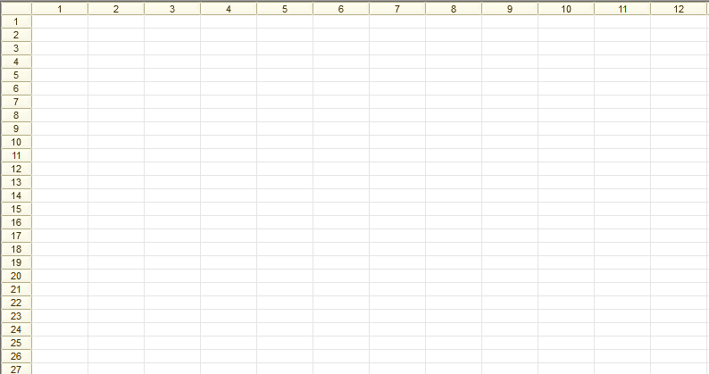
In order for the spreadsheet document to be filled in accordance with a certain structure, the Template configuration object is used. A template can be added to almost any configuration object: catalogs, documents, enumerations, all types of registers, all types of plans, reports, data processors, tasks, business processes.
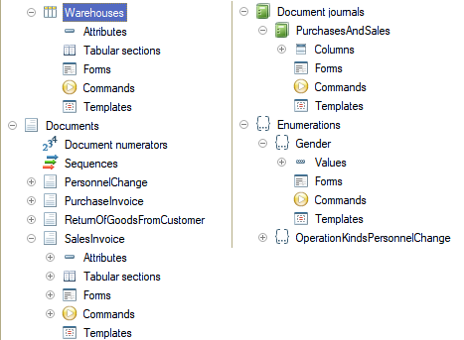
There are different types of templates and their use for the formation of a print form is not their only application. We will not consider all types now, we will talk only about those that are used in the mechanism of print forms: a spreadsheet document and a text document. The template type "text document" is used much less often than "spreadsheet document", it is used to form checks on a cash register tape and other forms that do not require maintaining a complex structure (tables, images, column widths, setting up text wrapping in cells, etc.).
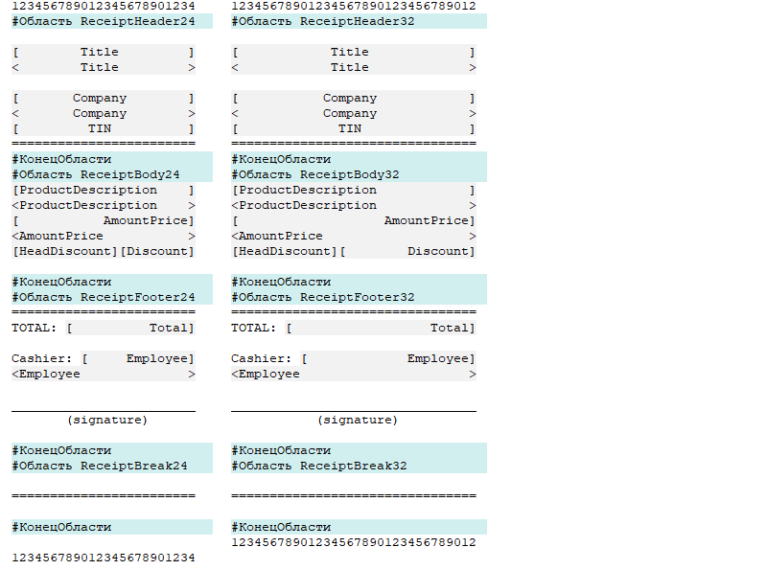
A template with the "spreadsheet document" type is actually the same spreadsheet document as the one used to output a finished print form, with the difference that it specifies "blanks" of data that can be filled with various data in order to form print forms for various objects. That is, the template defines the structure of the future print form or even print forms that differ in content, because one template can be used to print a document in several types, for example: with and without discounts, with and without taxation, with and without seals and signatures, etc. For ease of use, the template provides the ability to specify named areas (parts of the template) that can be obtained from the code for subsequent filling and output to the final spreadsheet document.
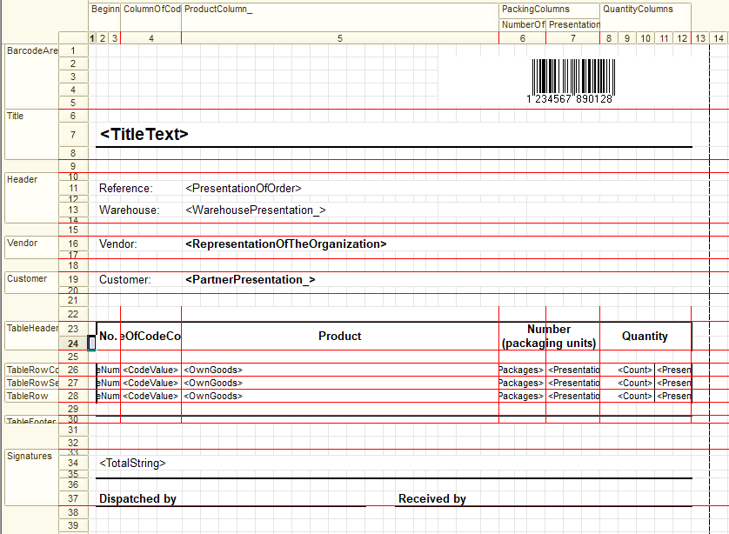
In general, the process of filling a spreadsheet document using a template looks like this:
- Get the template into a variable
- Get the template area into a variable
- If necessary, fill the template area with data, for example, data of an object that is the basis for filling out a print form
- Output the area to a spreadsheet document
Let's look at this algorithm using a simple example, but first, let's use the platform's built-in print form wizard to create a print form for the document SalesInvoice as quickly as possible.
The print form wizard is located in the "Wizards" submenu of the context menu of an object, which can be called by right-clicking on the metadata object or by clicking on the "Actions" submenu in the object editor window.
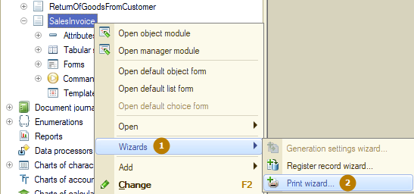
In the first window of the designer, you should select creating a new or editing an existing print command of the document. When choosing the option to create a new command, it is recommended to give it a clear name. Please note that this dialog does not check for spaces and prohibited characters in the command name, but the requirements for the command name are the same as the requirements for the metadata object name, since after the creation of the print form using the wizard, a new command and template will be created for the document.
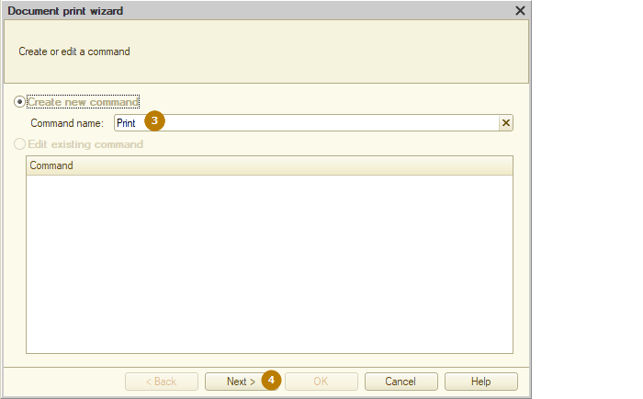
I specify the name "SalesInvoice" and proceed to the next step of the designer. At this step, you need to specify which document fields should be added to the header (top) of the print form.
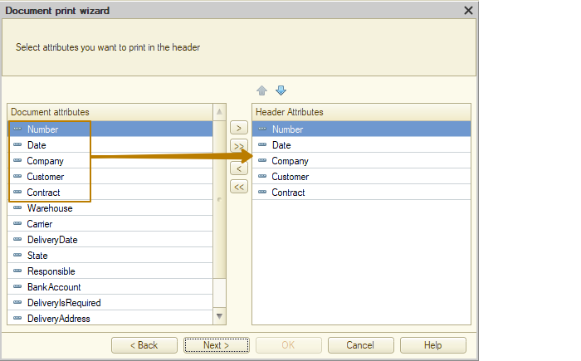
Then there will be as many steps as there are tabular sections in the document, in our case there are 2: Products and Services. I select all columns of the tabular sections for output to the print form.
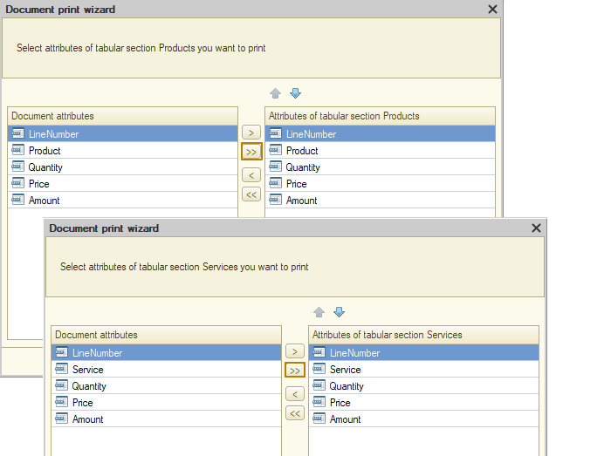
At the next step, we should specify which document fields should be output to the footer (bottom) of the print form. I add the total amount field, delivery fields, and information about the person responsible for the document.
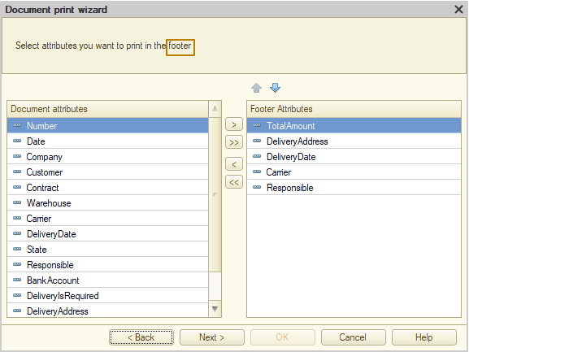
At the last step of the designer, we can choose in which panel the added print command should be displayed, by default this is the Form command bar of the "Important" type, as well as the settings of the spreadsheet document, such as: print without preview, view-only table, and table protection. "View-only table" prohibits manual editing of the spreadsheet document, and "table protection" in addition to prohibiting editing disables the context menu and the ability to copy data from the spreadsheet document.
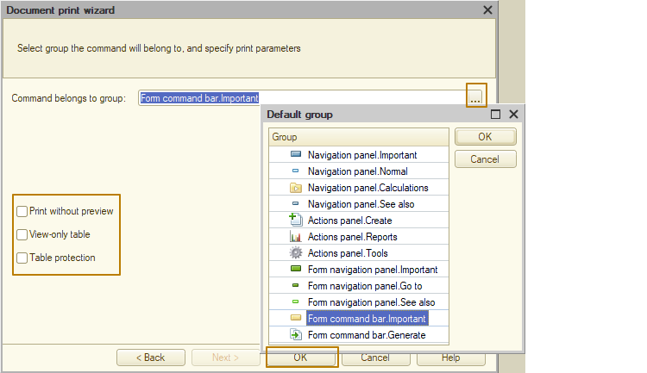
After clicking the "OK" button in a wizard form, a window with the generated template will be opened.
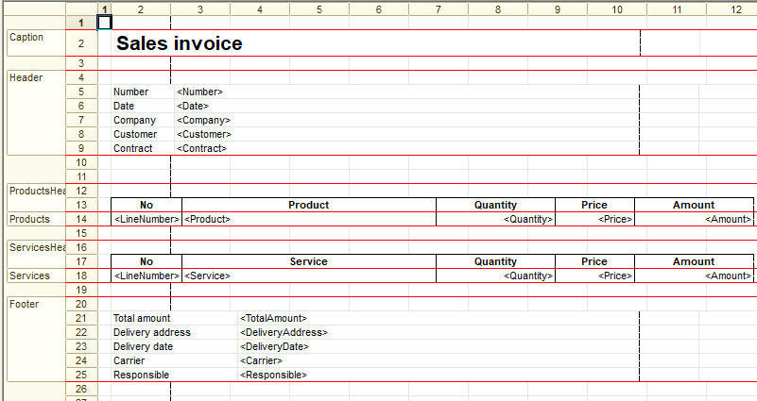
To the left of the row numbers you can see the names of the template areas, in the row itself they are highlighted with red lines at the top and bottom. These are row areas, in addition to them there are also column areas and cell areas, but we will talk about them later. The print form wizard created the Caption, Header, ProductsHeader, Products, ServicesHeader, Services and Footer areas, which are subsequently output to the spreadsheet document of the print form with data filling or without changes. In our case there are areas in which no information needs to be filled before outputting, for example, table headers contain column headings, such as “Product”, “Quantity”, etc.
All cells in the spreadsheet document have the "FillType" property. The fill type of the cells of the spreadsheet document in areas output without changes is "Text". Cells with text enclosed in triangular brackets (e.g. <Number>, <Responsible>) are of the "Parameter" type, which means that everything in such a cell will be filled programmatically. There is also a third type of cells that combines both approaches, this is the "Template" filling type. Inside a cell with the template type, there may be strings enclosed in square brackets, such as [DocumentNumber], [DocumentDate], which are the same parameters of the template area as cells with the "Parameter" type. They, like parameters, can be filled from code, but the rest of the cell text located outside the named areas will remain unchanged. An example of a template for generating a header:
<Sales invoice [DocumentNumber] from [DocumentDate]>
When filling in the DocumentNumber and DocumentDate parameters of the template area, for example, with data 12 and 15.08.2024, the result will be the text
"Sales invoice 12 from 15.08.2024" (although the date format depends on the regional settings of the infobase and may differ from what I specified).
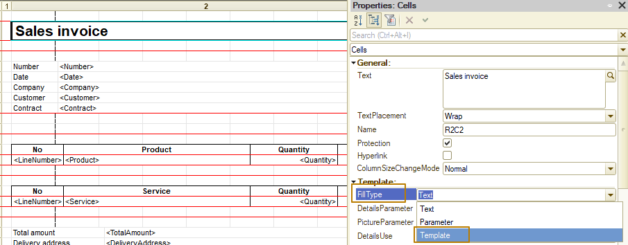
An example of the Template fill type:
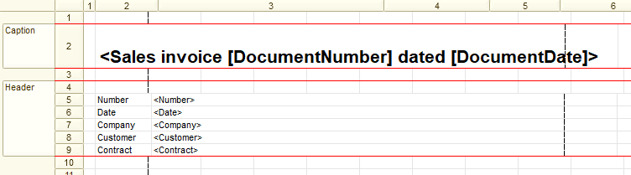
Let's look at the code that the platform automatically generated as part of creating a print form using the designer. Let's start with the code of the command module that was created for the document Sales invoice.
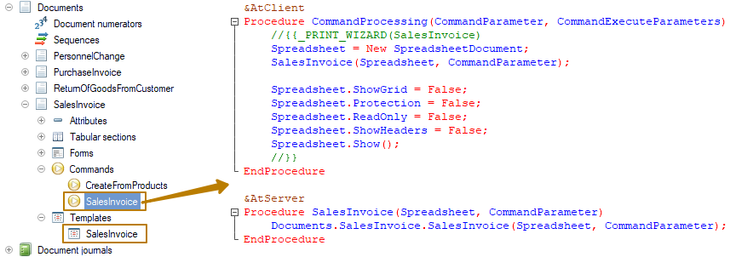
Here is the client procedure - command handler, in which a new object of the SpreadsheetDocument type is created, which is then passed to the server procedure, inside which there is a call of the procedure for filling in the spreadsheet document located in the document manager module (we will move on to this procedure immediately after completing the review of the current module). Then the code execution returns to the client, where the values of the properties "ShowGrid", "Protection", "ReadOnly" and "ShowHeaders" are set for the spreadsheet document. Protection and ReadOnly are set depending on the state of the flags at the last step of the designer. The last line of code SpreadsheetDocument.Show() opens a new form in which the filled in spreadsheet document is located and a user is given the opportunity to edit it, as well as print, preview and save to file.
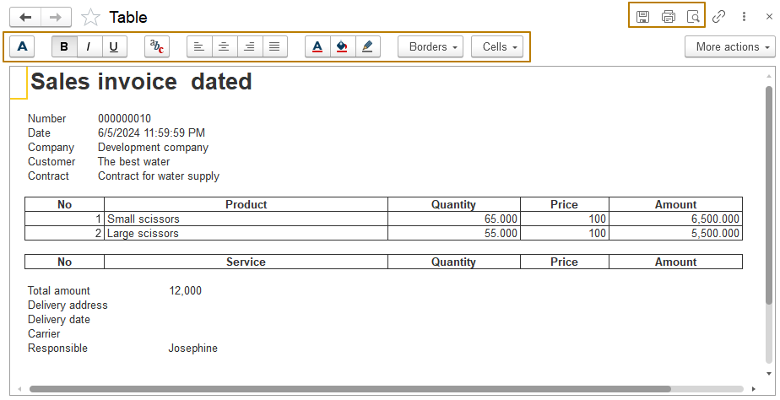
Finally, we move on to the document manager module, in which the platform created the SalesInvoice export procedure with the SpreadsheetDocument and Ref parameters.
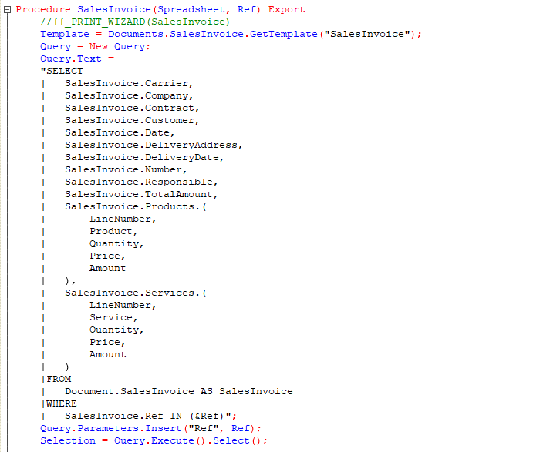
In the first line of the procedure, the document template obtained using the GetTemplate() method of the document manager, to which the template name is passed, is assigned to the Template variable.
Next, a query is generated for the document, in which only those fields are selected that were selected in one of the areas when using the print form designer. Then this query is executed and its result is selected in the Selection variable.
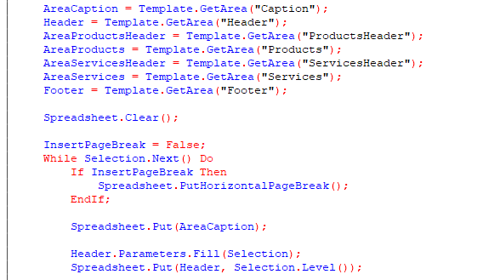
You can see that the GetArea() method of the template is used to write template areas to variables. Let's take a closer look at this method. In our case, the search for an area by name is used, but the search by address is also supported, where the first and last cells of the required area are specified in the format "RmCn:RxCy", where:
- m is the row number of the starting cell,
- n is the column number of the starting cell,
- x is the row number of the ending cell,
- y is the column number of the ending cell.
For example, GetArea("R2C2:R4C3") will return a 2x3 cell area (2 horizontally and 3 vertically), these will be columns 2 through 3 and rows 2 through 4, i.e. an area of 6 cells.
The method also has another syntax, when instead of passing a string denoting an area, you can pass the numbers of the first row of the starting cell, the first column of the starting cell, etc., similar to the previous syntax.
Example: GetArea(2, 2, 4, 3).
The code line SpreadsheetDocument.Clear() clears the spreadsheet document. This code is called here in case a spreadsheet document that was passed to the procedure containing some data.
The InsertPageBreak variable is set to the initial value False to not output the horizontal page break on the first step of the loop. The page breal is the part of the spreadsheet document that is the end of one page and the beginning of the next page in all modes of working with the spreadsheet document (print, preview, etc.). Similarly, in docx or pdf documents, you can see that the pages on which the data is placed are already marked up, i.e. there cannot be one infinite page (but the pages themselves can have different sizes in different documents, for example, A4, A5, etc.).
Next, there is an iteration of the selection records in a loop, within which the first action is to check whether a horizontal page break needs to be output. If so, it is output using the PutHorizontalPageBreak() method. The page break can also be vertical, but it is used extremely rarely, since the page is always limited vertically by the paper size selected in the print settings.
Note: the paper size can be changed not only in Enterprise mode, but also from the code; for this, the spreadsheet document has a PageSize property with the String type. For more details, see the description of the property in the Syntax Assistant.
To output the template area to a spreadsheet document, the Put() method is used, with the template area passed to its parameter. Such an output always occurs from a new line. There is another method, Join(), which adds the specified area to the last line of the spreadsheet document after the last column at that time. This method is useful in cases where the set of columns output to the print form depends on certain conditions. For example, the same procedure serves several print forms "Sales with discounts" and "Sales", or the output of discounts to the print form depends on the settings of the information base (for example, there is a functional option "use discounts"). Then the output of columns containing information about discounts to the print form can be implemented inside the checks for whether discounts are used.
In the Header.Parameters.Fill(Selection) line, the parameters of the "Header" template area are filled using the properties present in both the parameters of the template area and the selection. Not only a selection, but also any collections or objects whose properties can be accessed using the property names separated by a period (for example, DocumentInformation.Date) can be passed to the single parameter of the method. Please note that if you make the parameter name "Product" in the template area, and the data passed as a source of values does not contain such a property (but contains, for example, the "Item" property), the "Product" parameter will not be filled. In addition to such filling, parameters can also be filled using assignment:
Header.Parameters.DocumentDate = Format(Selection.Date, "DLF=D")
This method is used when the data must be prepared for output, for example, there is a complex algorithm for forming a complete representation of an organization, or if the final amount must be displayed not only in numbers, but also as a string (One hundred twenty-seven thousand three hundred dongs), for which there is a separate method in the general module. In general, there can be a lot of examples.
In the next line of code, the second parameter passed to the Put() method is the selection level (read the Level() method of the query result selection/iteration object) as the level of grouping the rows of the spreadsheet document. Using this parameter does not make sense without turning on and off the autogrouping of the rows of the spreadsheet document using the StartRowAutoGrouping() and EndRowAutoGroup() methods, respectively. Probably, this parameter is used in the code generated using the print form wizard so that the developer can add these methods in the right places, as well as edit the query text by changing it to multi-level, and then the rows of the spreadsheet document will be grouped by the specified levels. This row autogrouping looks like the ability to collapse and expand individual groups of rows using the "+" and "-" commands in the spreadsheet document. In the screenshot below, you can see an example after I added the changed code, adding the missing calls to it:
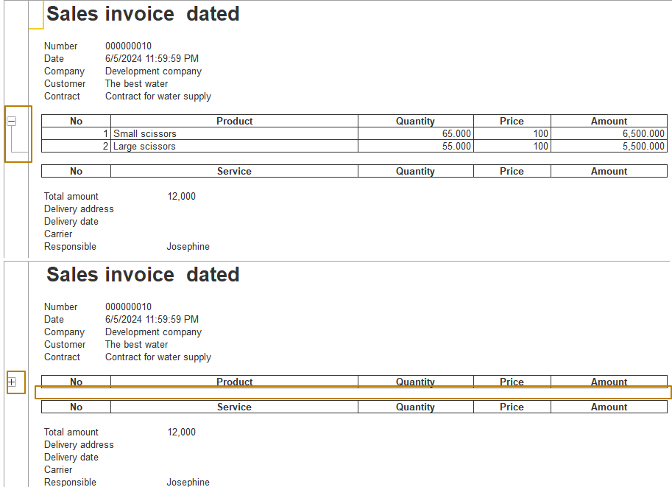
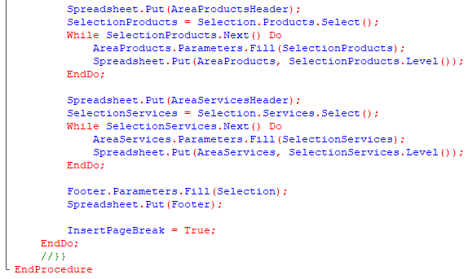
Next, the header of the product table is output, and then the products are selected into the SelectionProducts variable, since the tabular sections were selected in the query as nested parts of the object, then when selecting from the query result, these tabular sections are stored in separate query results and data from them should be obtained using selection or unloading to a table (Select() or Unload() methods of the query result). Then this selection is iterated with filling in the area parameters and outputting it to a spreadsheet document. In this case, the Level() method of the SelectionProducts object will return 0, because this is a new selection. This method returns non-zero values in cases where a selection is iterated by a query with totals (the TOTALS BY construction is used in the query).
The actions are repeated for the Services table section. Then the footer is filled in and output.
At the last step of the loop iteration, the InsertPageBreak variable is assigned the value True so that on all subsequent iterations of the loop, the horizontal page break is output before filling in the data for the next document. That is, the resulting print form supports printing for several documents at once (which can be selected in the document list form), each of which will start on a new page. This can also be seen by the condition "SalesInvoice.Ref In (&Ref)" in the query text. An array of references to documents that the user has selected for printing is passed to the Ref parameter of the current procedure.
Let's finally look at the result in Enterprise mode. The list form and the document form now have a print button on the form's command bar.
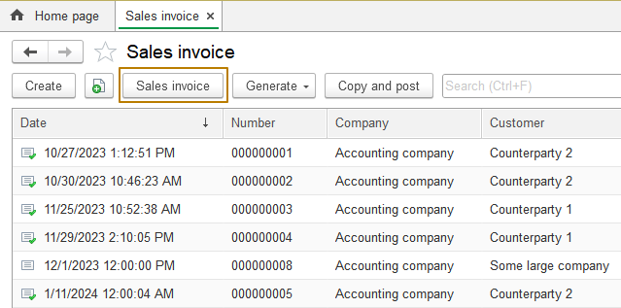
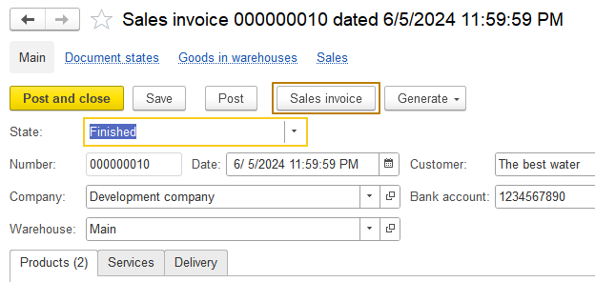
I remind you that you can print several documents from the list form. To do this, you need to select them (by clicking on the necessary documents while holding down the Ctrl key, you can also select document areas "from - to" while holding down the Shift key, and finally, you can use the Ctrl+A key combination to select all the lines in the list). I click the print button for one document to see the result.
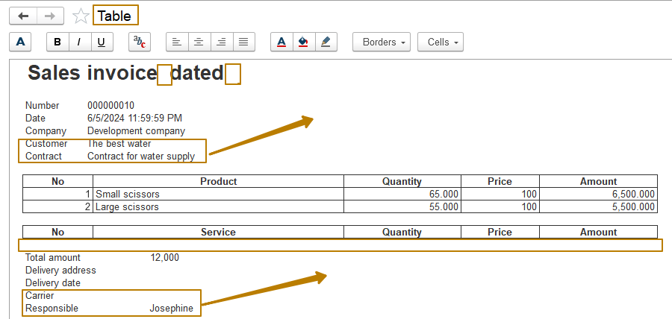
As you can see, the print form that we created using the wizard has a number of shortcomings:
- The form opened using the spreadsheet document method does not have a clear title, instead it says "Table"
- All attributes are displayed one after another vertically, while there is free space on the right to place some of the data
- The header of the Services table is displayed even when there is not a single row in the tabular section of services
It is also clear that the header of the print form is not completely filled in, but this is because I changed it in the template to demonstrate the type of filling in the "Template" cell, but did not add the missing code for filling in the template parameters.
This print form can be edited in the opened form before printing or saving to a file, because I did not turn on the "view-only table" or "table protection" flags.
I want to get rid of these shortcomings, and also change the title and header of the print form so that the number and date are displayed in the title, and are no longer displayed in the header (currently the text and parameters are displayed there: Number <Number> and Date <Date>).
I will not modify the resulting print form, but will develop a new one in order to demonstrate the creation of a print form from scratch without using a wizard. Since I no longer need the old print form, I delete the template and the document command, and also delete the procedure SalesInvoice from the document manager module and create a new export function PrintFormSalesInvoice, which takes one parameter PrintingObjects as input and returns a filled spreadsheet document. I will immediately write the code for creating a spreadsheet document and returning it from the function.
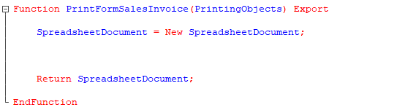
Now we can start creating metadata objects. I'll start with adding the print command SalesInvoice to the document. I select the "Form command bar.Important" group for the command, and the command parameter type is a reference to the document itself, the parameter usage mode should be Multiple so that several documents from the list can be printed.
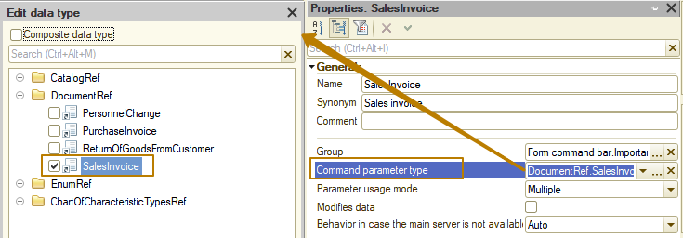
Since calling the method from the object manager module is only available on the server (the client context knows nothing about metadata classes such as Catalogs, Documents, etc.), I need to create a server method in the command module and call it from the client. The new server function contains only one line - returning the value that the print function returns from the document. After receiving the spreadsheet document on the client, it must be shown to the user using the Show() method, where the first parameter can be the title of the window to open with the spreadsheet document.
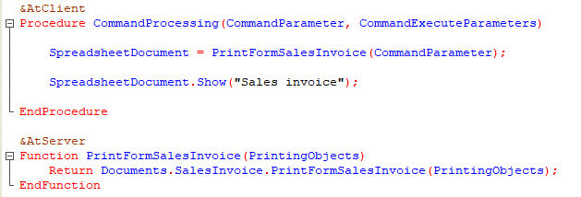
Next, I need to create a template and describe the code for filling it.
I add a new template with the type "Spreadsheet document" and call it PF_SalesInvoice. I use the prefix "PF_" to indicate that this metadata object is used as a print form, since templates can have other purposes, i.e. in the future, you can immediately understand the purpose of the template by its name.
For most print forms, I recommend first of all setting the column widths in the template to the same value and focusing on the template width for an A4 sheet of 40 columns in order to make it easier to work with such a template in the future (since it will be possible to more flexibly adjust the width of the columns of tables and other fields).
I select columns 1 through 40, right-click on any of them and select "Column Width...", where I specify the value 2.75 in the Column Width field.
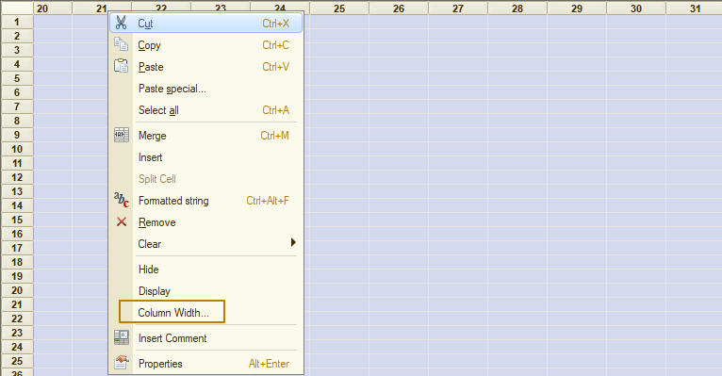
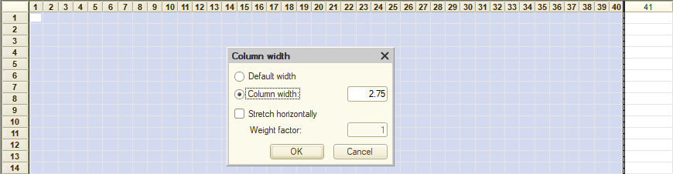
Now I make indents from the edge on the right and left so that with any setting of the fields on the print, my print form has indents from the edges of the sheet. To do this, I will reduce the width of the first and fortieth columns and in the future I will not fill the cells in these columns. Columns can be selected by holding down the Ctrl key, after which set the same width for them - 0.9.
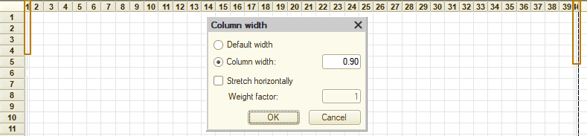
Note: in templates with the spreadsheet document type, the column width has a minimum step of ~0.125, which means that when setting a width that is not divisible by 0.125, the width you enter will be rounded down to 0.125 (which in turn is also rounded down to 2 decimal places). Please take this into account when setting the column width.
In our case, if we reopen the width of column 1 or 40, we will see the value 0.88 there (i.e. it is 7*0.125 = 0.875 ~0.88). If we try to set the column width to 0.87, it is less than 0.875, so it will be rounded down to the next step, i.e. to 0.75.
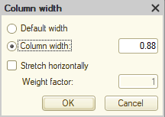
Now I want to create template areas and fill them. For easy template readability, developers recommend arranging areas in the same order in which they will be output to the print form. So let's start with the Title area. In the print form built through the wizard, I used a cell with the "Template" fill type so that the title immediately contained the date and document number. Let's make exactly the same title in the new print form.
I leave the first row empty so that the text is more convenient to perceive in the development mode and now I need to merge all the cells in row 2 for columns 2 through 39, then click the "Merge cells" button, which is located on the "Spreadsheet Document" toolbar.
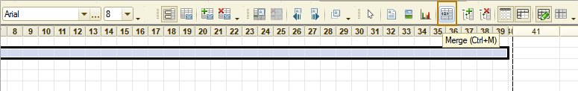
This panel can be disabled or can be located in another part of the working window, for example, under the opened window at the bottom above the panel of open windows. Toolbars can be turned on and off from the context menu called by right-clicking anywhere on the panels.
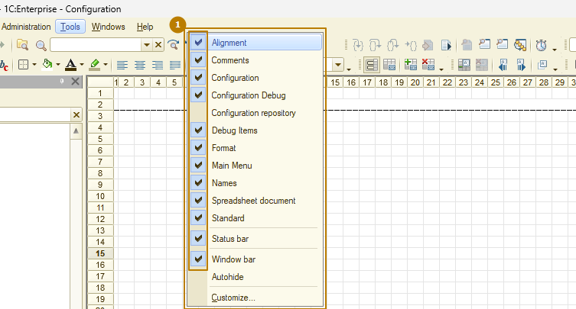
All commands are located in the Table menu and are grouped there by purpose.
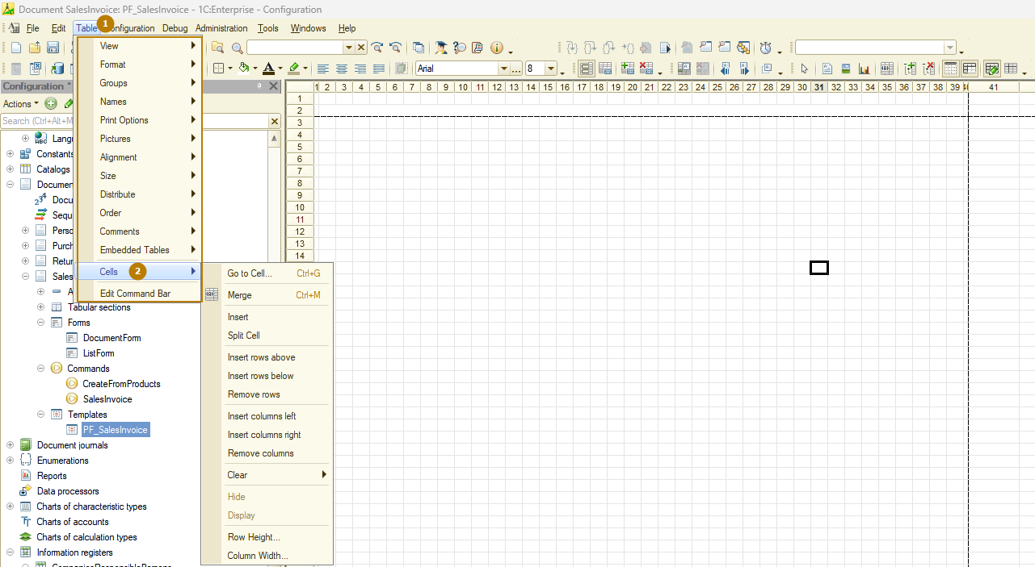
As a result, I got a merged cell, for which I set the Arial font, size 12, bold. I set the cell fill type to "Template", horizontal alignment "centered", then I write in the cell "Sales invoice No.[DocumentNumber] from [DocumentDate]". After exiting the cell editing mode, the text in it should be in triangular brackets, if this is not the case, check that you have correctly set the "Template" fill type for the cell.
Now I need to create the Title area, which will include this line. To do this, I left-click on the line number (in this case, it is number 2) and go to the Table menu - Names - Set name ... In the window that opens, I enter "Title" and click OK.
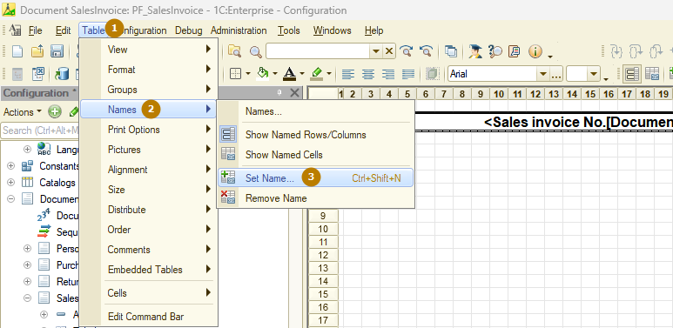
To delete the area, you need to click the command below - "Remove name". You can also see all named areas of the template and work with them from a separate window, which can be called from the menu Table - Names - Names…
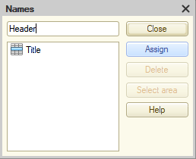
Next, I create the Header area, in which I place the main attributes of the object, such as company, customer, contract. To do this, I need to select several rows that are combined into an area. If I need an empty row between the areas output to the spreadsheet document, I must have an empty row or rows in the area. I make the Header area from 3 rows - I will leave row 1 empty as an indent from the title, and in rows 2 and 3 there will be document attribute data.
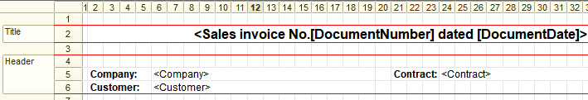
Note: you can change the number of rows in the area for all areas by inserting and deleting rows, except for the area of 1 row. In order to make a multi-line area (in 2 or more rows) from a single-line area, you can use the "split cell" command of the cell context menu with the choice of the "vertical" splitting method, or delete the area, then select the desired number of rows and create the area again.
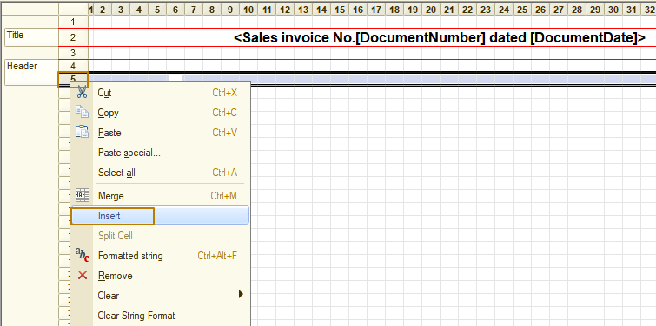
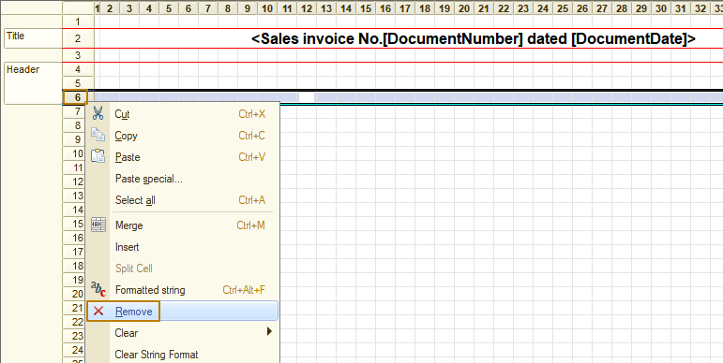
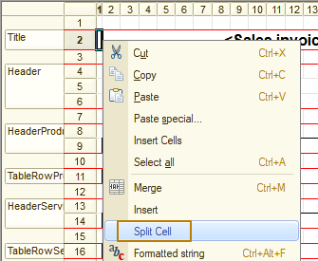
Tip: To rename an area, you can use the Table - Names submenu, or double-click on the area header
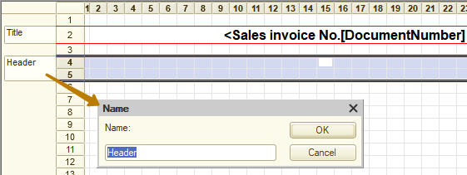
Then I change the font size in the next 20 lines from 8 to 9 and start filling the Header area. I merge the cells to place the "Company:" and "Customer:" headers, and after the headers, I merge the cells to place the Company and Customer parameters there. At the same time, I do not need to occupy the entire line, since the presentation of the company or customer is unlikely to take up more than half of the line. Therefore, in the line with the customer, I place the header and the Contract parameter on the right: <Contract>.
Why don't I use the Template filling type for these attributes? The fact is that the font and color settings affect the entire contents of the cell, so if I want the attribute headers to be highlighted, for example, in bold, but not the attribute values, I cannot place the header and value in the same cell. That's why I split them into separate cells, now I'll highlight the headings in bold.
Let's move on to the HeaderProducts area, which will only contain static text. I merge the cells, roughly estimating the width required to display data for the Products tabular section, make the font bold, and then draw the cell borders.
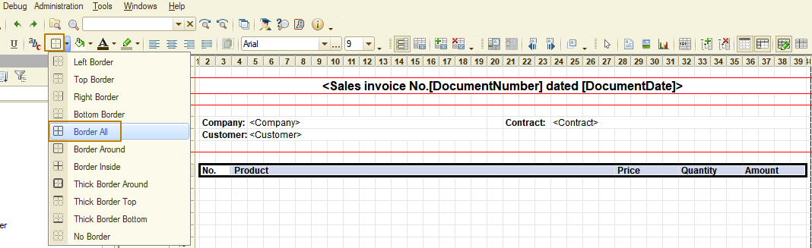
I don't forget to assign a name to the area for the entire row - "HeaderProducts". Since the Products and Services tables will only be printed if there are rows in the corresponding tabular sections, I indent the table by adding an empty row to the HeaderProducts area before the table. Thus, if the table is printed, it will be added with an indent.
The ProductsTableRow area, on the contrary, will consist entirely of parameters that will be filled in from the code. Once again, I draw your attention to the fact that if you want to use the Fill() method of the Parameters property of the template areas, the parameter names must match the names of the properties of the collection that you will pass to the method. Therefore, it is better to name the parameters filled without additional processing from the code the same as the attributes of your object so that when selecting a query, you do not have to worry about renaming the fields.
In order not to spend a lot of time creating areas for the Services tabular section, I can copy the product areas and rename the areas, as well as different text/parameters. To do this, I need to select the entire rows (exactly the rows, not the cell ranges) by clicking on the row numbers in the template.
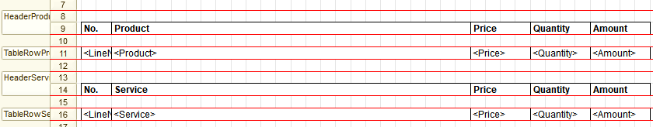
I also want to output the document's total amount in this print form after the products and services tables. To do this, I create a separate "Totals" area, in which I place the "Total:" text and the "TotalAmount" parameter. If my document did not have an attribute that stores the document's total, I would have to write code that first assigns 0 to a variable, and then adds the row's total to this variable in loops that go through the Products and Services tables, for example:
TotalAmount = TotalAmount + ProductsRow.Amount;
But since my document has an attribute that stores the already calculated value, I don't have to do this, I just have to make sure to select it in the query. I also don't forget about the indent from the last row of the table.
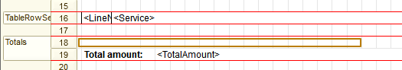
The last area of the template, "Footer", in which I place data about the person responsible for the document and the warehouse from which the goods must be shipped. To avoid typos when creating fillable parameters, you can copy attribute names from the metadata tree and paste them into cells, or simply drag attributes into the template with the mouse (however, dragging will break the cell merging).
Let's take a look at the final template
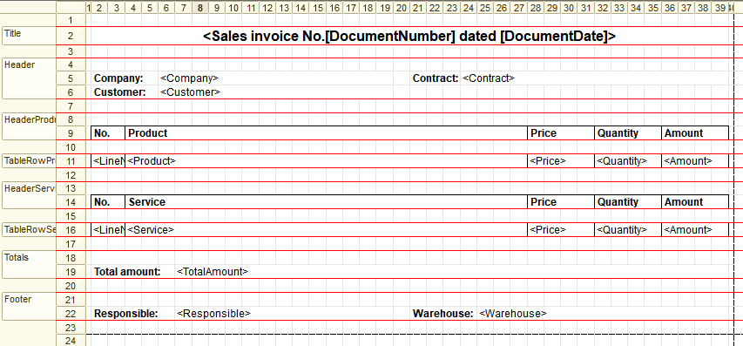
Now I need to write code to fill the spreadsheet document with data based on the resulting template. To do this, I go to the PrintFormSalesInvoice function of the document manager module and first of all write a query that selects the necessary data. I do not select data that I will not need when filling out the print form, you can also see that I renamed the Date and Number fields to DocumentDate and DocumentNumber so that they are called the same as the parameters in the template.
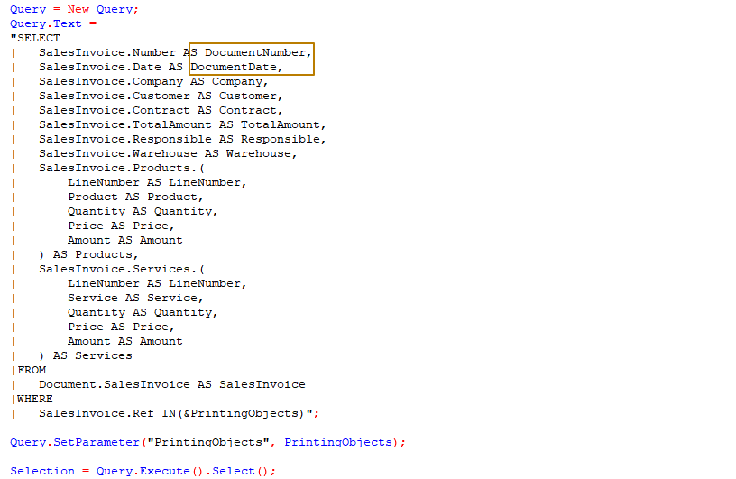
Next, I need to get the template into variables, and then get all its areas into variables too.
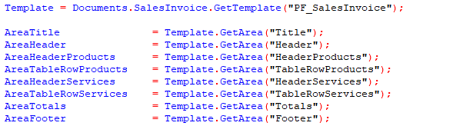
Let's move on to filling in the template in the "Title" area of the print form. In order for the date to be displayed without the time, there are two ways to format it: 1) using the global context method Format(), 2) by setting the template cell format in the Format property. It makes no sense to use the format in the template for cells with the "Template" fill type, since the value in such cells is usually a combination of strings and numbers/dates/boolean values, and the format will only work if the entire value in the cell has a single type, which must be converted to a string of a certain format.
Format of the value from code:
AreaTitle.Parameters.DocumentDate = Format(Selection.DocumentDate, "DLF=DD");
Format of a cell of a template:
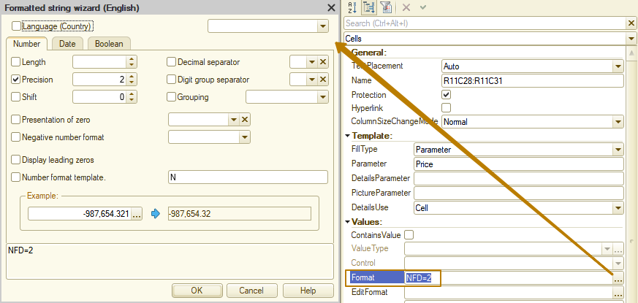
Note: filling in the format from the code has a higher priority than the cell format, that is, if the format is filled in from the code, and you want to change the format to some other one, then changing the template cell format will not give a result, you will have to edit the code.
Note: the value written to a cell determines the horizontal alignment in that cell in cases where the "HorizontalAlign" property value = "Auto". Numbers are automatically aligned to the right, strings to the left. For example, when using a cell format in a template, the type of the value in the cell will be the same as the type of the value placed in the template area parameter. But when changing the format programmatically using the Format() method, the value in the cell will always be "String", since the Format method returns a string. Therefore, in cases where cell alignment is very important to you, specify it yourself.
Now I update the DB configuration and run the infobase in Enterprise mode to see the result. I check the print form on a document that contains both goods and services.
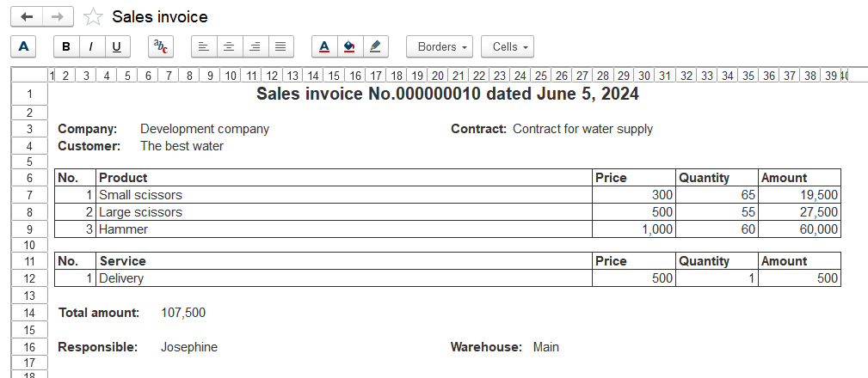
Let's take a look at the placement of the print form on the page using the preview function.
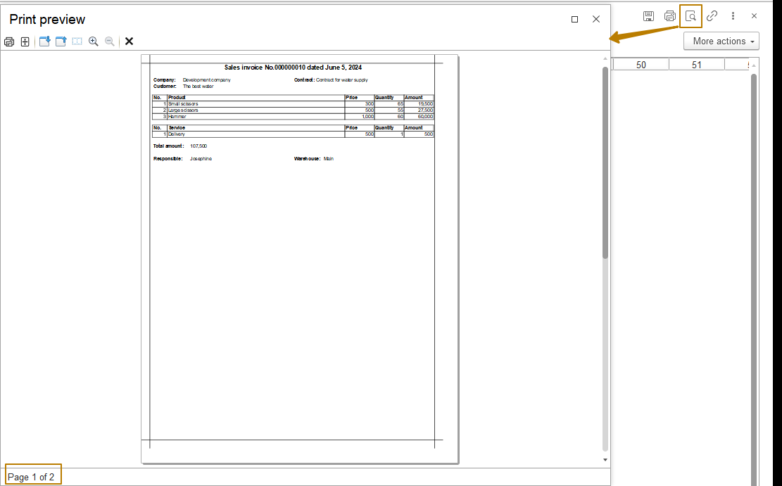
As you can see, the resulting print form does not fit on 1 page, although visually it seems that everything is fine. Whether the print form fits on 1 page is affected by such parameters as: margin size (fields group), paper size, page orientation, and scale. They can be seen and edited in the page setup window, which can be opened from the preview window.
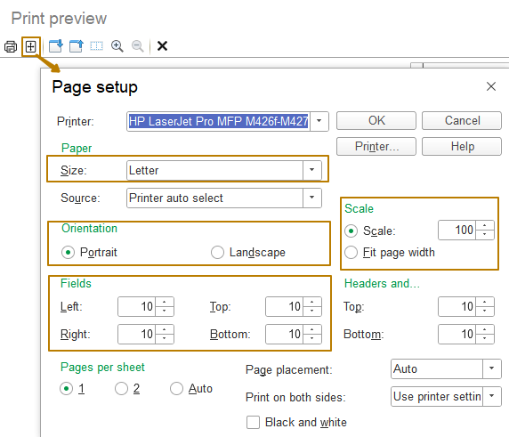
In order for your printed form to fit the page size even if a user changes a number of parameters, it is recommended to use the FitToPage property of the SpreadsheetDocument object, assigning it the value True. In this way, the platform will fit the print form data onto the page taking into account the other parameters.
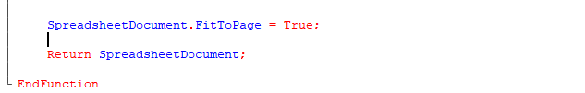
Note: it should be understood that the more the print form does not fit onto the page, the more its scale will be reduced, so this method is not suitable for very wide print forms. Sometimes it is better to change the orientation to landscape in order to print a wide document.
In order for the user not to change the page parameters every time before printing, we can save them for each print form. To do this, use the PrintParametersKey property of the spreadsheet document, which must be assigned a string value that allows you to uniquely identify the print form. Page parameters are saved separately for each user. Different values of this property must be assigned for different print forms (unless you want different print forms to have common print parameters), usually the key is made up of the object name, the underscore character and the name of the print form, for example:
SpreadsheetDocument.PrintParametersKey = "SalesOfGoodsOfServices_SalesOfGoodsOfServicesWithDiscounts";
Attention: after changing the print parameters key of a spreadsheet document, the platform will try to get the page parameters for the new key, if there is no saved data for the new key for the current user, the page parameters will be reset to the default settings, so you should be careful when changing the value of this property.
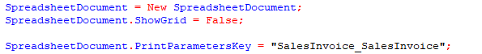
The code for filling out the print form is not particularly different from the code that was generated by the wizard earlier, so I will not dwell on it in detail.
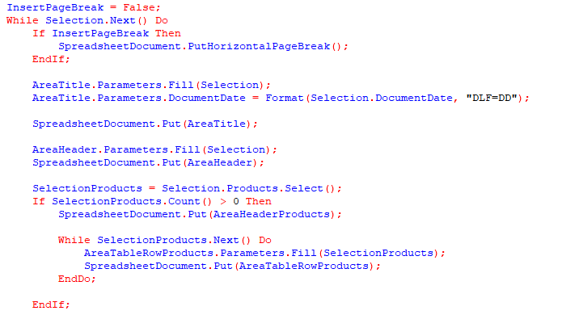
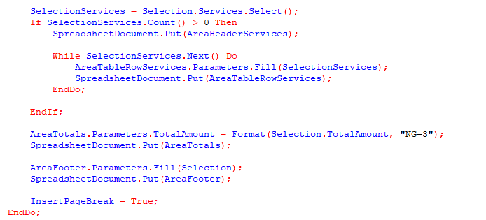
Working with images
In addition to text in a spreadsheet document, you can work with various drawings, these can be shapes, a drawing for subsequent filling with text, a drawing for subsequent image replacement, a fixed picture, diagrams, etc.
Let's consider a drawing for subsequent image replacement, since this type of drawing is quite common in print forms, because with the help of this object you can insert logos, seals, signatures into print forms. This data cannot always be fixed in the printed form without changes, because they depend on other data, for example, the logo depends on the company from the printed object, the signature depends on the responsible person, the seal can depend on both.
Let's implement the ability to specify and store the company's logo in the Companies catalog, as well as output the logo to the print form Sale invoice. To do this, I create the LogoPicture attribute with the ValueStorage type in the Companies catalog.
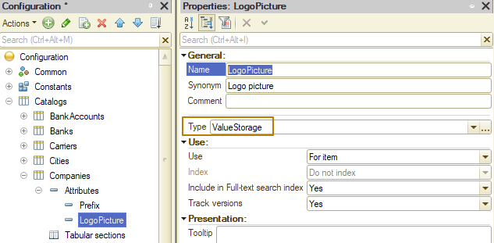
Note: ValueStorage is a special value type that allows you to store data of various types, including complex ones, such as images (binary data). The value stored in the value storage cannot be changed directly, you can only overwrite the value storage with a new value. For more information about this type, see the syntax assistant.
To display an image on a form, you should use an image field associated with a form attribute of the String type. The value of such an attribute must specify the address of the binary data of the image in the temporary storage of the infobase.
Note: temporary storage allows you to store any serializable value for some time within one session of working with the infobase. For example, when calling the server from the client, you need to return a value table. But since the value table is not available on the client, you can place it in temporary storage, and return the address in the temporary storage to the client. After receiving the address, you can call the server method from the client, if necessary, in which you extract the value table from the temporary storage to execute some algorithm. For more information about this type, see the syntax help.
I create the LogoPictureAddress attribute in the form, display the element associated with it on the form and select the "Image field" field type. In order to select the logo by clicking on this field, I enable the "Hyperlink" property of the field. Next, I want to make the interface more understandable for the user so that he understands how to work with the image field. To do this, I fill the NonselectedPictureText property of the image field with the value "Add logo" and change the text color to Light Gray. Now, when the image is empty, the text will be displayed in the field. In order to separate this field from the others, I add this form element to the group with the Logo title, and disable the title in the "TitlePosition" property of the element.
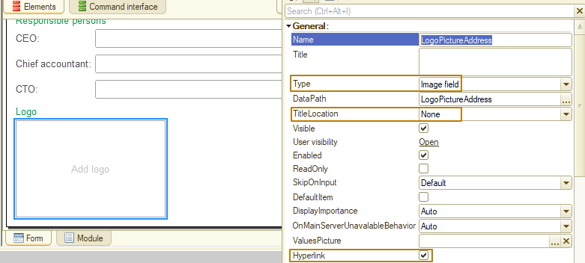

Important: an important part of working with images is setting the appropriate image size in the field. In order for the image to adjust to the size of the field, you must select the "Proportional" value of the PictureSize property.
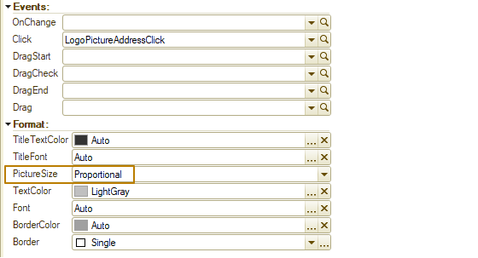
Next, I need to create a handler for the Click event of this field. In the handler, I disable the standard processing, otherwise when clicked, a window will open with a string value of the attribute (an empty string or the address of the image in temporary storage). Then I use the LockFormDataForEdit() method to lock the current company object for editing, so that no one can edit it at the time the user selects the image.
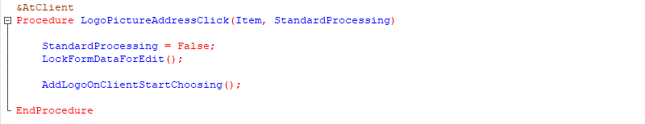
The next step will be working with the file selection dialog, which allows the user to select a directory or file, and also specify the path and name under which the file should be saved.

File dialog:
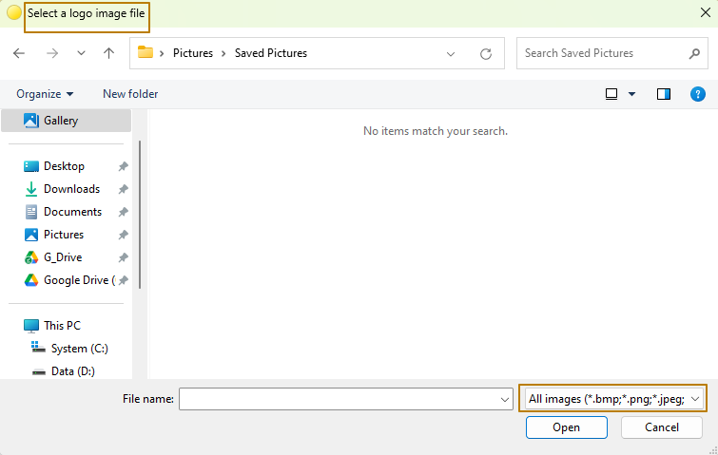
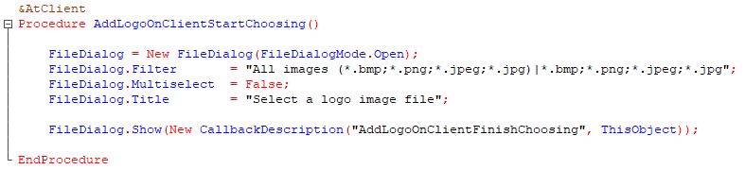
When selecting a file, I use the Filter property to limit the list of file types so as not to see inappropriate files. I disable multiple file selection, because we need to limit the selection to only one image, and also fill in the title so that the system window contains a clear inscription for the user. After that, I can open the dialog using the Show() method, passing it a callback description of a procedure that will be called when the file selection dialog is closed.
As you can see, I placed the work with the file selection dialog in a separate procedure so that in the future this procedure could be moved from the form module to the common module if it is necessary to call it from other objects (for example, I want to implement adding a logo to the Products catalog).
Now I create a procedure-notification handler, I remind you that it must be Export. The list of parameters of this procedure can be found in the syntax assistant for the Show() method of the FileDialog object. The first parameter SelectedFiles can take a value of one of two types: 1) an array with paths to the selected files, if the user selected at least one file; 2) Undefined, if the user refused to select (pressed the Esc key, clicked the Cancel button, or closed the window by clicking the Cancel button). The second parameter contains AdditionalParameters that could have been specified in the callback description (if they were not specified, the parameter takes the value Undefined).
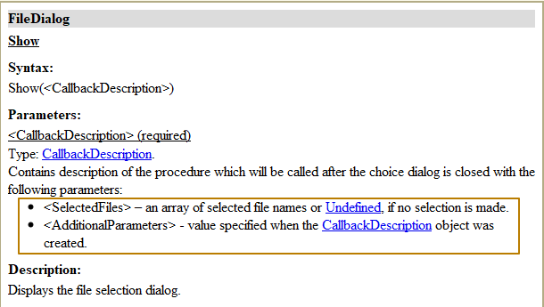
Now I implement the check whether the SelectedFiles parameter is equal to Undefined. If so, I break the code execution. Otherwise, I get the file name from the array at index 0, since I disabled multiple selection for the dialog, which means that the array can only contain one path to the file. Since the user could specify a non-existent file (after selecting the file, it was moved/renamed/deleted by the user, and the user could also enter the file name from the keyboard), it is necessary to check the existence of the file before trying to get its binary data. This can be done by creating a file object using the New File (FileName) constructor and then calling the BeginCheckingExistence method of this file. This method requires passing the callback description as a parameter, the first parameter in the notification handler procedure is Exist of the Boolean type. It indicates the result of the file existence check. Since the local variable FileName is outside the scope of the notification handler procedure, I pass this data through the callback description to the AdditionalParameters parameter of the notification handler procedure.
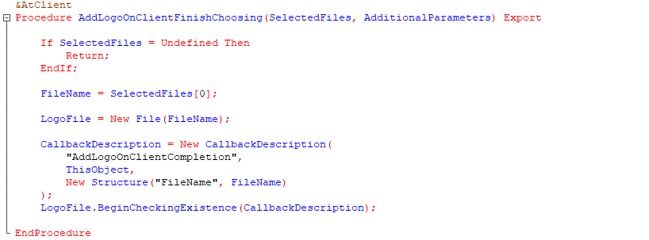
In the handler procedure, I first check the result of the check - if the file does not exist, I inform the user about the error and break the code execution. If the file does exist, it is necessary to create binary data by its full path:
BinaryData = New BinaryData(FullFileName)
, place it in temporary storage, passing there the unique identifier of the current form, so that the address in temporary storage is not cleared during the next server call (read the details in the syntax assistant for the PutToTemporaryStorage method). I write the received address to the form attribute LogoPictureAddress.
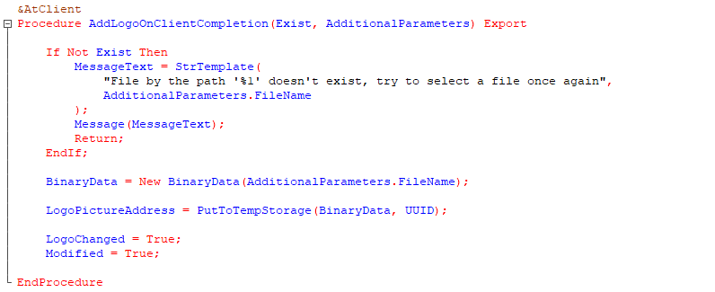
Now I add the form attribute LogoChanged of the Boolean type, and at the end of the last procedure I add two lines of code:
LogoChanged = True;
Modified = True;
In the first line, I mark in a separate variable that the logo has been changed, which means that before writing the object, the binary data of the image must be placed in the value storage (the LogoPicture attribute of the catalog). In the second line, I set the form modification so that the platform displays the standard question about writing the changed data when the user closes the modified form.
Let's check the work in the Enterprise mode. I open the form of the Companies catalog item and click on the image field, the file selection dialog opens.
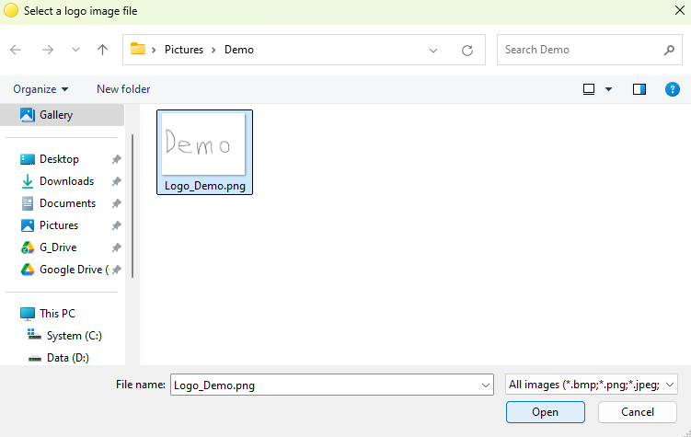
I select the image file and click Open. The file selection dialog closes and I see the image in the field on the organization form, as well as the form modification flag.
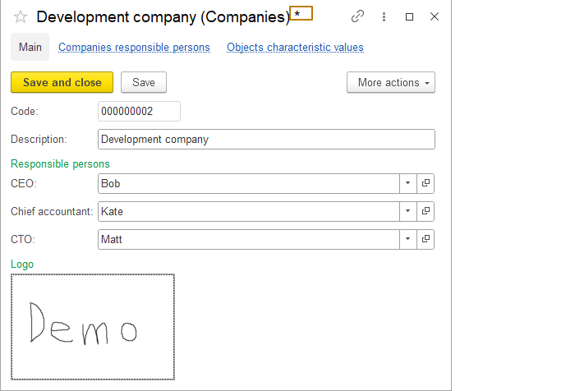
Now I click "Save and close" and open the form again. I see that the logo is empty again. This is logical, because I did not describe the process of saving binary data to the ValueStorage type attribute, as well as the reverse process of extracting binary data from the value storage and placing them in temporary storage so that the image field reads the image at the address in the temporary storage.
Since the platform has a limitation on accessing the value storage type attribute through form data, I need to work not with the main Object form attribute, but with the object itself, which is available in some form event handlers. To read data from the value storage, I use the OnReadAtServer event handler, and to write to the value storage, I use the BeforeWriteAtServer event handler.
The value storage has only one method - Get(), which returns the value from the storage. I will use it to read the value into a variable. Since the storage may not have a value, the returned value in this case will be Undefined. Therefore, I check the type of the value by comparing it with the BinaryData type, if so, I place the binary data in temporary storage, and write the address to the LogoPictureAddress attribute.
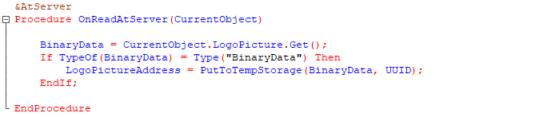
Now we need to describe how to place binary data in the value storage. To do this, we first need to retrieve the binary data from the temporary storage at the address specified in the LogoPictureAddress attribute.
This is where the LogoChanged attribute created earlier comes in handy. I check if the logo has been changed, and if so, I retrieve the binary data from the temporary storage and then write it to the value storage by assigning the attribute of the new value storage. Note the second parameter of the value storage constructor, it specifies compression, which in turn accepts the compression level parameter, where -1 is the default compression level, 0 is no compression, and 9 is the maximum compression level. Potentially large data should always be compressed as much as possible so that the database size does not grow too much.
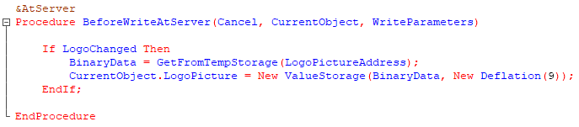
I update the database configuration and run the database in Enterprise mode again. Here I repeat the steps and now the image is saved and displayed when the form is reopened.
This completes the work on saving the image in the object, it remains to implement its output to the print form.
I open the template and increase the height of the Title area to 4 lines and shift the text of the title to the right so that a rectangular shape for placing the image fits on the left. To add an image to the template, you need to select the cell and click "Picture" on the toolbar or from the menu Table - Pictures - Picture…
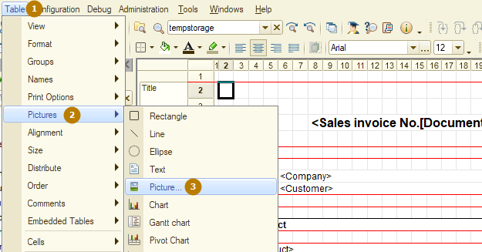
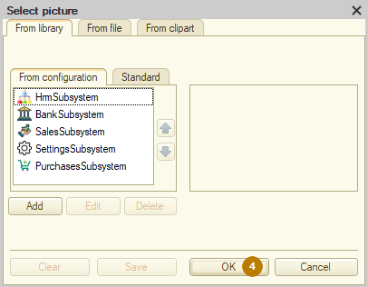
In the menu that opens, you don't need to select a picture, just click OK. A shape for the picture will appear in the cell, since the picture is not selected, the shape has a minimum size. I stretch and move this shape.

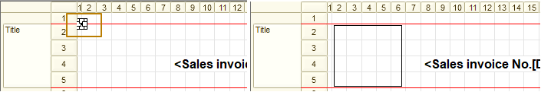 This shape for the picture is called a spreadsheet document drawing. An object of the SpreadsheetDocument type has a Drawings property that stores a collection of drawings, this property can be used not only for the template, but also for the template areas, since each area is also a spreadsheet document. In the picture properties, it is advisable to specify a unique name by which you can refer to this deawing, I specify "Logo", and also set the "picture size" property to "Proportional".
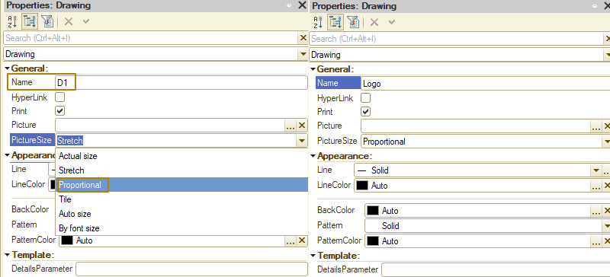
Now it remains to implement the filling of the drawing area with a picture from the code. First, I need to write a function that returns the binary data of the logo stored in the property with the ValueStorage type of the Companies catalog. I place such a function in the catalog manager module, and do not forget to make it Export.
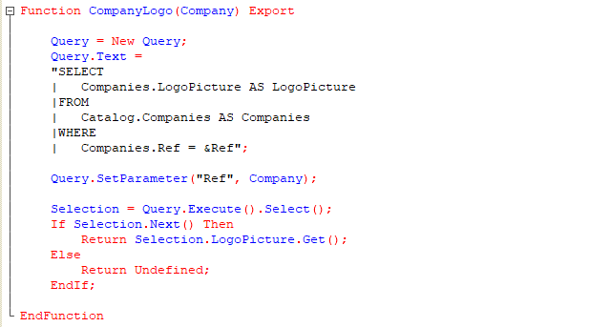
Now I go to the algorithm for filling the spreadsheet document and call the new function, receiving the value in the CompanyLogo variable. Since some companies may not have a logo filled in, I need to check the value type for equality to the BinaryData type. If so, I create a new picture using the New Picture(BinaryData) constructor, and then set this picture to the Picture property of the spreadsheet document drawing.
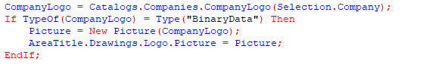
Now I update the configuration and check the result.
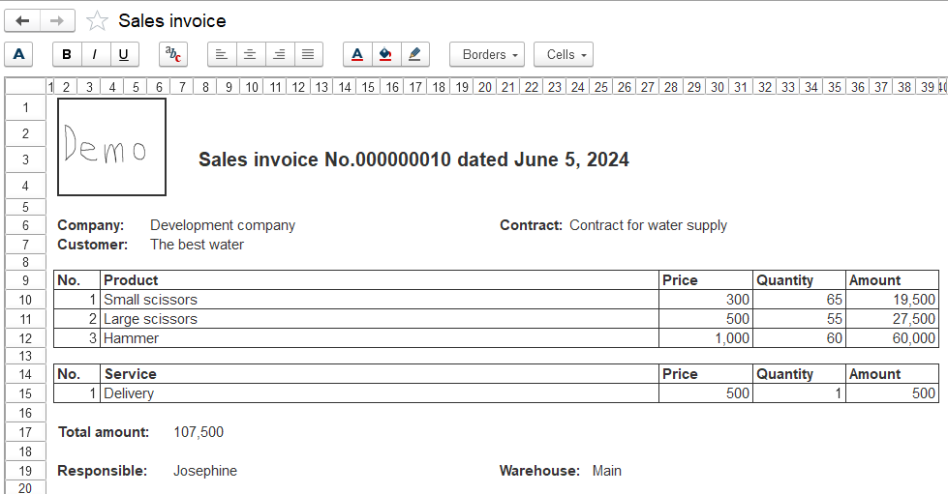
As you can see, everything worked out, but the frame around the logo looks unnecessary, I suggest getting rid of it. This can be done either through the properties of the drawing in the template, or programmatically when filling out the spreadsheet document.
To change through the properties of the drawing, it is enough to set the value "None" for the "Line" property. To change programmatically, you should assign a new line to the Line property of the drawing of the spreadsheet document:
AreaTitle.Drawings.Logo.Line = New Line(SpreadsheetDocumentDrawingLineType.None);
I use the first option and change the line of the drawing in the template, since I am of the opinion that the template should look as close as possible to the final appearance of the print form. The only disadvantage of the absence of a line in the template is that then such a drawing is not visible until it is selected.
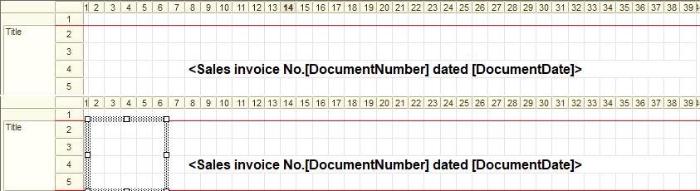
However, this can be changed using the Pattern property of the spreadsheet document. In this property, you need to select the "Solid" value, and it happens that for a new drawing this property is initially set, but it does not work correctly and the drawing looks transparent, so you can simply select this value despite the fact that it is already active.
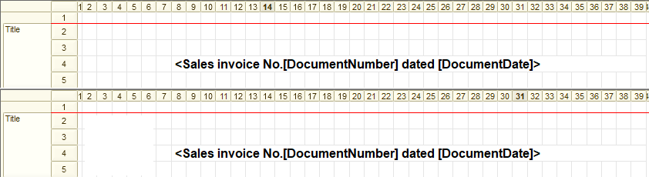
Now you can see the drawing as it has a white background.
Reports with programmatic template filling
So, it's time to master one of the key tools of business applications - reports. Reports allow you to get structured and easy-to-analyze information from the database. Complex reports can take data not only from the current, but also from other databases, including databases not on the 1C platform, but this is a complex topic in which it is also necessary to learn the integration mechanism, we will not touch on it in this course. In the current lesson, we will only begin to get acquainted with this type of metadata and learn how the already acquired knowledge about filling a spreadsheet document based on a template can be applied to build reports. The main work with reports will be studied in the next lesson, since reports with programmatic filling of the template are used quite rarely, while most reports are built on the basis of templates of the "Data composition scheme" type, which are part of the mechanism of the Data Composition System of the 1C platform.
A report with programmatic template filling works on the same principle as a print form. There is a spreadsheet document and a template, according to which the spreadsheet document will be filled. The difference is that the report usually contains the period for which data should be taken, as well as some parameters/filters. What is the difference between parameters and filters? Parameters are often mandatory for filling, i.e. without them the report should not be generated, also parameters can be more complex than filters. For example, filters are directly linked to the data, according to which the report is built and/or which are output to the report, this can be a filter by product, counterparty, company, warehouse. Parameters can be such as "show balances: 1) only non-negative; 2) only negative; 3) all", i.e. this is some additional logic that the developer has embedded in the report for more convenient work with the output of data. Or "Product type: 1) all; 2) goods; 3) services", where when selecting goods or services in a query, filters are imposed, and when selecting the "all" option, filter by product type is not imposed, so records are selected for all products.
Also, for such reports, we need to develop your own form, on which we need to place the "Generate" button, as well as the period, parameters and report filters, if any. And, of course, add the report to the command interface.
Let's start creating a report with programmatic template filling. First, I create a new report, call it SalesByCustomers and add it to the Sales subsystem. Next, I create a Sales template with the SpreadsheetDocument type. In the template, I will need the Title, HeaderProducts, and RowProducts areas. Since the sales in the report should be displayed by customers, I will make the report multi-level using the auto-grouping of rows, which we have already become familiar with in the topic of print forms. Then, instead of one RowProducts area, I make 2 areas: RowCustomer and RowProduct.
I want the report title to look like "Sales by customers from <Start Date> to <End Date>". You already know that you should use the Template cell fill type for this.
Since the grouping levels in the table will be different (product rows are nested within customer rows), I highlight the customer row in color.
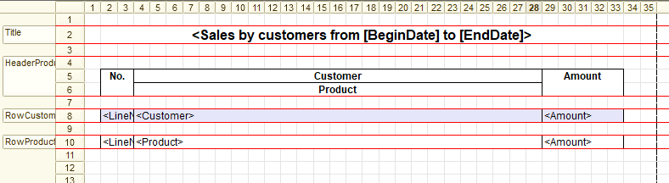
Let's move on to creating a report form. I create a form with the "Report form" type. The command bar is filled with the "Select option...", "Settings..." commands, and the "More actions" submenu. They are displayed on the form's command bar because they are used in reports based on the data composition system, but I don't need them in the current report, so I disable autofill of the command bar in its properties.
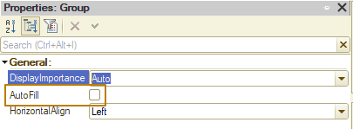
I create the "Generate" command, I will need command handlers on the client and on the server. I add a button for this command to the command bar and enable the "DefaultButton" property.
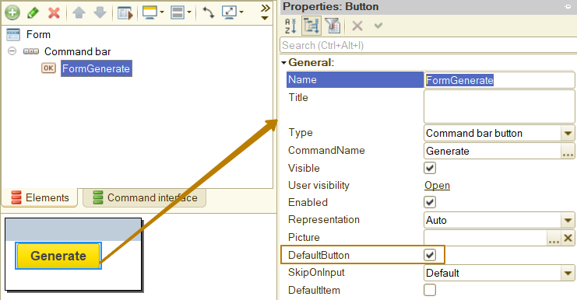
Next, I need to place a spreadsheet document field on the form. I create a form attribute Result of the SpreadsheetDocument type and drag it to the form. I do not need a title on the form for this field, so I select "No" in the "TitlePosition" property. It is better to restrict editing the data of the spreadsheet in the report for a user, so I enable the ReadOnly property of the field.
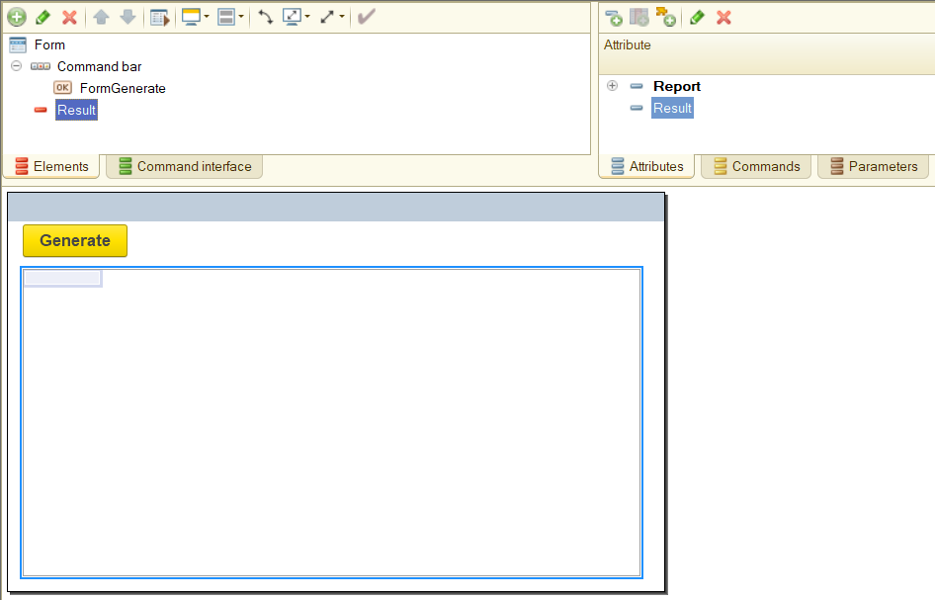
In order to give a user the ability to select the report period and filter by products, I create the Period attribute with the "StandardPeriod" type and the "Products" attribute with the "ValueList" type, for which I select CatalogRef.Products in the "ValueType" property of the value list. Next, I create a collapsible group with the "Parameters" heading and add fields to it for the newly created attributes (I add the list of items as a field, not as a table). For the user's convenience, I enable clear buttons for these fields by selecting the "Yes" value in the "ClearButton" property of the fields.
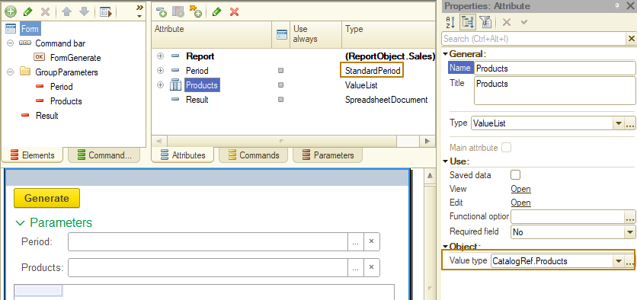
The template and form are ready, all that remains is to write the code for generating the report. There is practically no difference here from the print form, which we have already learned how to generate. The difference is that after filling out a spreadsheet document, you do not need to open it in a new form using the Show() method, because the form with the spreadsheet document is already open, and also that there are optional filters that need to be applied if the user has specified values, or not applied if the user has not specified them, for example, the user can specify the start date, but not specify the end date in the standard period. Then the report should select all records later than the start date.
So, I will start filling the GenerateAtServer procedure with code. The first thing I need to do is clear the spreadsheet document in the Result attribute:
Result.Clear();
Next, I get the template and its areas into variables.
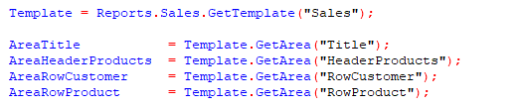
Now I have to write a query to the data in such a way as to take into account the period being empty (especially the end date, since if you set an empty date as the value of this query parameter, then only records up to the date 01.01.0001 will be selected) and the Products list being empty.
The resulting query is as follows:
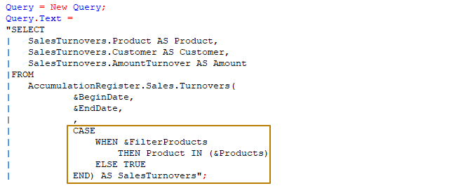
As the parameter FilterProducts, I will set the value ValueIsFilled(Products), so that in the case when this value list is filled, the value of the parameter will be True and only records where the product is included in the specified list will be selected, but if the list is empty, the value of the parameter will be False and all register records will be selected. With the end date, you can do it easier - I check if the end date of the standard period is filled, if it is not filled, then I set the value Undefined for the query parameter, since in this case the virtual register table will return records up to the current moment. If the end date of the standard period is specified, I bring the date in the query to the end of the day in order to select records including this day.
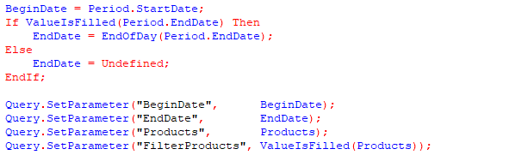
Since I want to make the report multi-level, where products are specified by customers, I need to change the query so that it is also multi-level. I do this using query totals: I group records by customers, summing up the data in the Amount field.
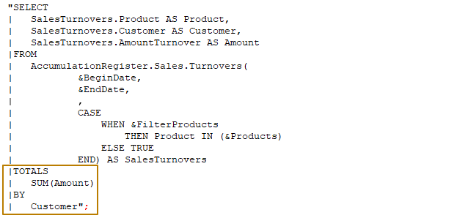
Finally, I can move on to filling the spreadsheet document with data, outputting the template areas to it. I execute the query, placing the query result in a variable. Next, I fill in the parameters in the Title area and output the area to the spreadsheet document. Then I output the HeaderProducts area to the spreadsheet document. Next, I check the query result to see if it contains records, if not, I interrupt the code execution.
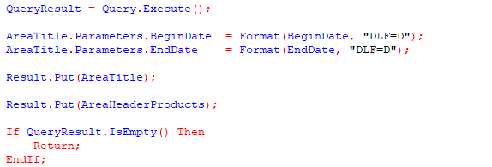
To group rows, I need to start autogrouping using the spreadsheet document method. Then I select data from the query result into the selection with an iteration by groups, so that the first selection level will contain summarized sales data for customers as a whole, and the next level will contain data on product sales.
I want to fill in the line numbers by item with a double number N.M, where N is the top-level number (that is, the line number of the current customer), and M is the line number of the product within the current customer. To do this, I initialize separate variables, one before the iteration by customers, and the other inside iteration , before the iteration by products. When outputting template areas to a spreadsheet, I need to pass the second parameter, the level, to the Put() method. This level can be obtained using the selection method of the same name: Selection.Level().
At the end of each of the iterations, do not forget to increment the variables with line numbers. After the iteration, I end the autogrouping of the rows.
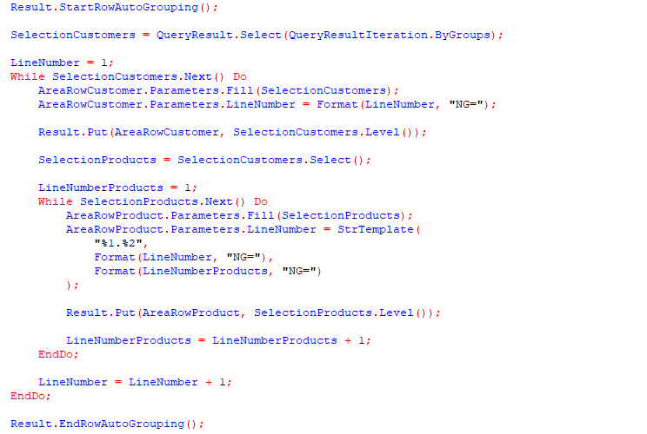
Now I update the DB configuration and run the enterprise mode to check what I got.
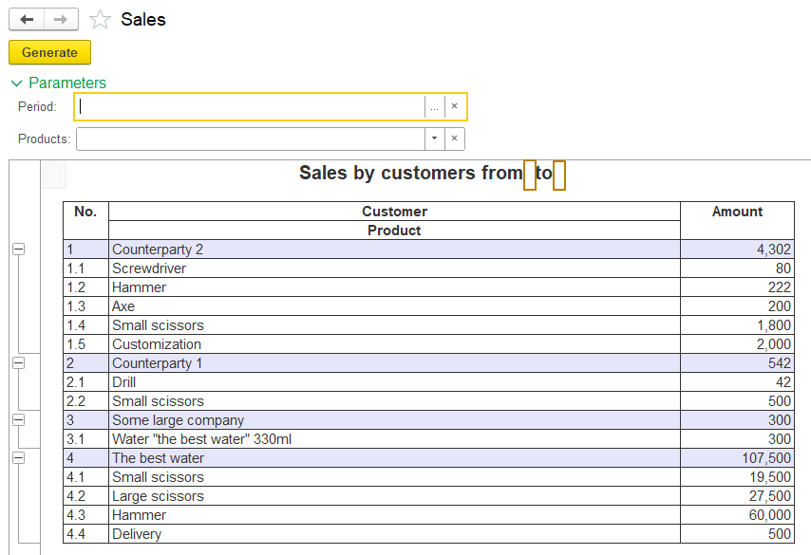
Overall, the report looks working, the period and filters affect the composition of the selected data, but the title does not look very nice, since it does not take into account the unfilled period. I suggest changing the algorithm as follows:
- If the start and end dates are filled in, the header = "Sales by customers from []"
- If only the start date is filled in, the header = "Sales by customers from []"
- If only the end date is filled in, the header = "Sales by customers to []"
- If none of the dates are filled in, the header = "Sales by customers"
To do this, I must make the header a parameter in the template, and it will be filled entirely from the code.
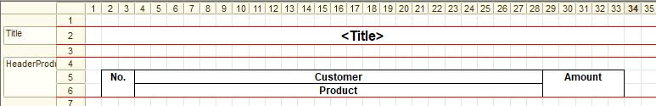
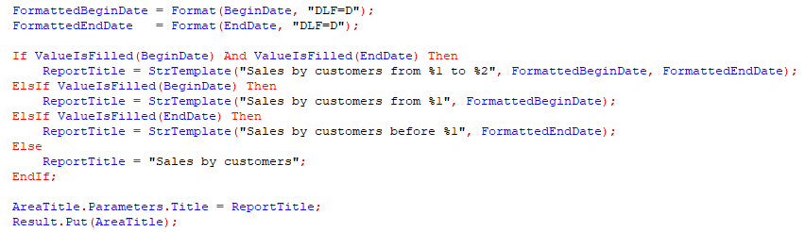
I check the result, now the report works correctly
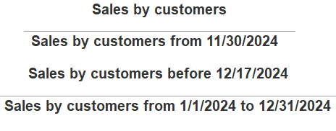
This concludes our introduction to reports. I would like to point out once again that this report format is used extremely rarely because the user cannot change the report structure, use their own filters, or save report options so as not to fill in parameters and filters each time. Such reports are used in cases where it is not possible to use reports based on the data composition system (DCS) for some reason. In the next lesson, we will get acquainted with DCS reports and you will see how to create user-friendly reports as quickly and easily as possible.

